VOIP 2

-Tanishk Singh

Purpose

The lab is performed with the intent to learn the definition and the successful configuration of *voicemail, music on hold, custom ringtone* and *dial in and out* on the IP phones*.* We the students, would show multiple results to our instructor to get this lab checked off and to ensure a proper knowledge on the configuration of the skills mentioned above. Like the names suggests, we had to enable voicemail system on our IP phones, so that we could send and accept voicemails on the phone from any mobile device. During the configuration, we, just like the Internal VOIP lab, would utilize another virtual server known as the *Cisco Unity Connection*, and exhibit our skills on that virtual machine. To ensure a proper functioning of music on hold, we had to, during the call, press the hold button on one of the IP Phones so that the receiver could hear a custom music through his/her/their phone. We also had to make and feed a pristine song/music in our CUCM server and through that, to our phone, and set it as that phone’s ringtone. Dial in and dial out basically means that we had to configure the phone to acquire the ability to call anyone in the world and receive calls from anyone that has the mobility services, on this planet. We had to ensure the working of this process by calling our phone, and then using our phone to call our IP phones. For this process, we had to resort to the 2811 routers which had the *FX0 ports* which were specifically configured to enable this process.

Background Information

Voicemails are vocal messages that someone can leave for individual that they are might be trying to contact. One can access their voice messages directly from their phone, but their administrator must set up their voicemail account and set up their phone to access the voicemail system. The Messages button on their phone acts as a speed dial into the voicemail system. The voicemail system is not part of the phone. The voicemail system is a separate system that the phone and the call server communicate with to give one voicemail capability. When someone is not at their desk, they can call their voicemail system to access their voicemail. Typically, an individual’s voicemail system has a phone number that they can dial directly and then follow the prompts to log into their voice mailbox. The administrator can give them the voicemail system phone number. The voicemail system on the IP Phones is instituted with the employment of a CUC server and creating a successful trunk connection of the local CUCM server with it.

Cisco Unity Connection is a robust unified messaging and voicemail solution that provides users with flexible message access options and IT with management simplicity. Cisco Unity Connection lets users access and manage messages from an email inbox, web browser, Cisco Jabber, Cisco Unified IP Phone, smartphone, or tablet. Unity Connection also provides flexible message access and delivery format options, including support for voice commands, speech-to-text transcription, and even video greetings.

By default, IP phones, when set to “hold” during a call, either transmit a beep sound or remain silent. In today’s day and age, however, numerous companies have been using the music on hold system to provide their receivers with the leisure to enjoy their music while the conversation has been paused. The MoH system is set up using the CUCM server installed in the LAN. For more information on deploying the CUCM server on VMWare, kindly refer to the “Internal VOIP lab.”

Usually IP Phones provide the administrator with a bunch of, but still limited options to choose a ringtone for the IP phones. Due to these extremely limited options to choose from, it becomes highly possible that the administrator might not be able to find the ringtone that they desire to set on the phone. The process of uploading a ringtone on the CUCM server, which transfers the file on the IP phone is a multiple step procedure. A file located in the CUCM server, Ringlist.xml file must be downloaded using *tftpd32* and customized on notepad to add the ringtone that the user would upload on CUCM. Not any music file can be uploaded and used as a ringtone on IP phones. A certain audio file extension, “.raw” files must be made using *Audacity*, and then uploaded on CUCM.

Tftpd32 is a lightweight application that integrates multiple services into a single program and allows you to easily transfer files. It features a TFTP server and client, along with SNTP, SYSLOG, DHCP and DNS servers.

Audacity is a free and open-source digital audio editor and recording application software, available for Windows, macOS/OS X and Unix-like operating systems. In addition to recording audio from multiple sources, Audacity can be used for post-processing of all types of audio, including podcasts by adding effects such as normalization, trimming, and fading in and out.

Using IP phones to be able to call out to the world and to be able to receive calls from anyone in the world, is a very valuable skill to learn. The process is completed with setting route patterns on the CUCM server and some configuration of the FX0 interfaces on the router. FXO stands for foreign exchange office. An FXO port is an interface that connects your Plain Old Telephone Service (POTS) line to a VoIP adapter. It designates a telephone signaling interface that receives POTS (plain old telephone service).

Lab Summary

The lab commenced as per our instructor’s provided topology. We began by configuring OSPF area 1 on our network and quickly moved on to configure EIGRP 20. The redistribution process requires just a single command on each routing protocol being utilized in the LAN, which we executed. The metrics were conventionally set up on the EIGRP configuration, such that, it would set the reliability to out desired result, but would not do so with our delay. We, then, changed the k values under the EIGRP router configs to accommodate and correlate it with our delay and reliability. We later, configured the EIGRP Ads, such that it would make the AD of an externally learned route through EIGRP, 105. The process required us to execute a single command on all the nodes orchestrating EIGRP.

Lab Commands

|  |  |
| --- | --- |
| voice-port [port] | Interface that is to be configured as a voice port - the one that is connected to the phone. |
| signal [groundstart]  timing hookflash-out 50  timing guard-out 1000 | Type of signal wanting to be used |
| connection plar opx [phone number] | Sets the phone number to be reached |
| caller-id enable | Shows caller-ID - the phone number |
| ccm-manager config server [server address]  ccm-manager config | Points router to CUCM server |
| mgcp call-agent [server address] service-type mgcp version [version number]  mgcp profile default | Points the router to CUCM server |
| dial-peer voice 10 voip | Dial in setup start command |
| destination-pattern [phone number] | Phone number to be called (dial in) |
| session target ipv4:[server address] | Directs the call to the dial in phone number to go to the server address (dial in) |
| dmtf-relay h245-signal h245-alphanumeric | Allows for signal to be released (dial in) |
| dial-peer voice 1 pots | Dial out starting setup command |
| destination-pattern 9T  direct-inward-dial | Sets the routing pattern, in this case 9 is the extension and T is timeout (dial out) |
| port [outgoing port interface] | Sets the outgoing interface (dial out) |
| forward-digits [number] | Sets the number of digits dialed (dial out) |

Network Diagram

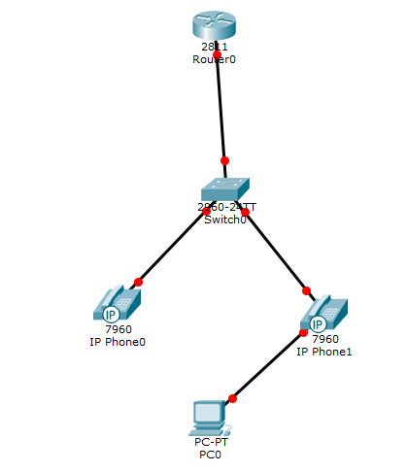

Configurations

Router 1 Configurations:

hostname R1

no aaa new-model

resource policy

memory-size iomem 10

no network-clock-participate slot 1

ip subnet-zero

ip cef

no ip dhcp use vrf connected

ip dhcp pool Voice

network 172.16.0.0 255.255.255.0

default-router 172.16.0.1

option 150 ip 172.16.0.2

ip dhcp pool Data

network 172.16.0.16 255.255.255.240

default-router 172.16.0.17

option 150 ip 172.16.0.2

voice call send-alert

voice rtp send-recv

voice service voip

h323

interface FastEthernet0/1.1

encapsulation dot1Q 10

ip address 172.16.0.1 255.255.255.240

no snmp trap link-status

interface FastEthernet0/1.2

encapsulation dot1Q 20

ip address 172.16.0.17 255.255.255.240

no snmp trap link-status

voice-port 0/3/1

signal groundStart

timing hookflash-out 50

timing guard-out 1000

connection plar opx 1111

caller-id enable

ccm-manager config server 172.16.0.20

ccm-manager config

mgcp call-agent 172.16.0.20 service-type mgcp version 0.1

mgcp profile default

dial-peer voice 10 voip

destination-pattern 1111

session target ipv4:172.16.0.20

dtmf-relay h245-signal h245-alphanumeric

dial-peer voice 1 pots

destination-pattern 9T

direct-inward-dial

port 0/3/1

forward-digits 11

telephony-service

max-ephones 2

max-dn 2

ip source-address 172.16.0.20 port 2001

create cnf-files version-stamp 7960 Jan 22 2015 23:53:36

max-conferences 8 gain -6

transfer-system full-consult

scheduler allocate 20000 1000

ntp master

Switch 1 Configuration:

hostname S1

vlan 10

name Voice

vlan 20

name Data

int range fa0/3 - 4

switchport mode access

switchport voice vlan 10

switchport mode access

switchport access vlan 20

int fa0/20

switchport trunk encapsulation dot1q

switchport mode trunk

Configuration Screenshots

Music on Hold:

Step 1:

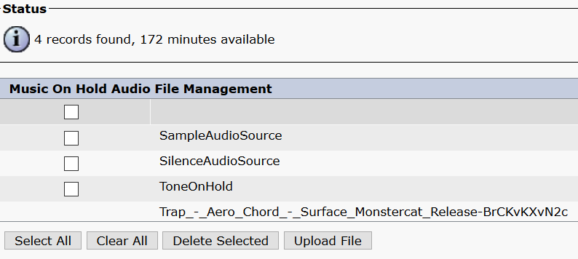

Upload the music file using the “Upload File” button and select the music file.

Step 2:

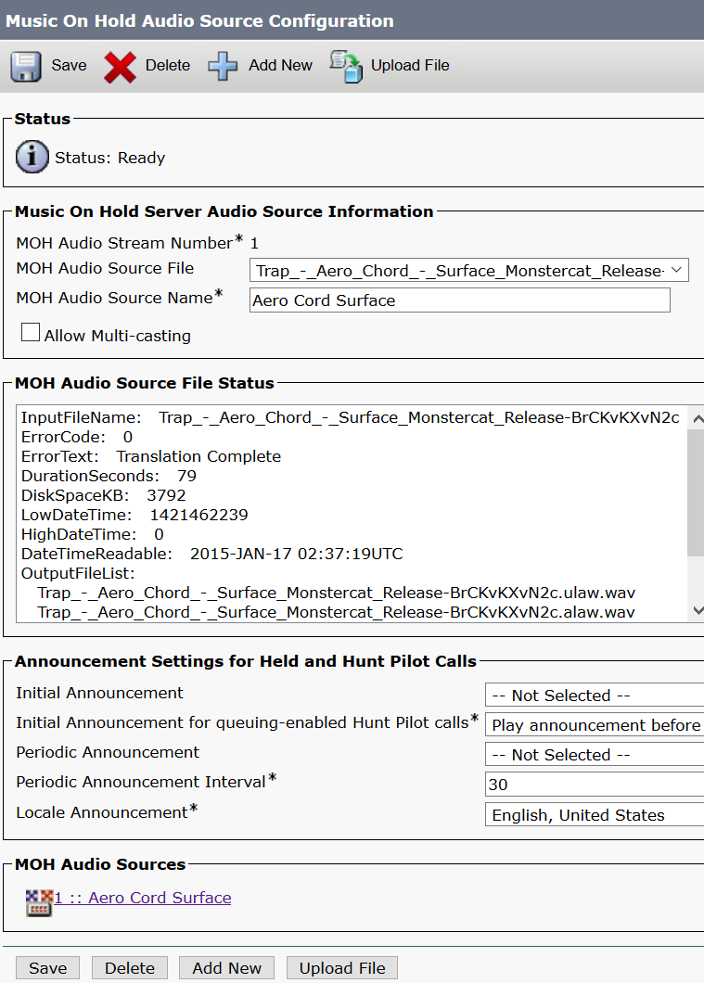

For “Music On Hold Audio Source Configuration”:

Set a name for the music file in the “MOH Audio Source Name” field.

In the “Initial Announcement” dropdown, leave it at “--Not Selected--”.

In the “Initial Announcement for queuing-enabled Hunt Pilot calls” dropdown, choose “Play announcement before”.

In the “Periodic Announcement” dropdown, leave it at “--Not Selected--”.

In the “Periodic Announcement Interval” dropdown, choose the number of seconds wanted to pause between each repeat of the announcement (default is 30 seconds).

In the “Locale Announcement” dropdown, choose “English, United States”.

Any fields with asterisks (*) should be filled in or selected.

**Custom Ringtone Configuration:**

Step 1:

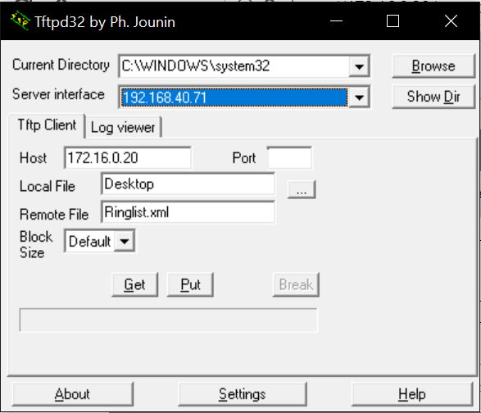

Use Tftpd32 (or any tftp software you are comfortable with) to retrieve the Ringlist.xml file from the VM server to edit.

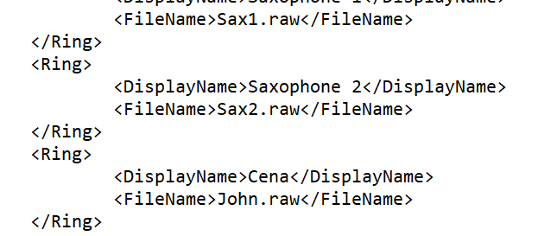

Set the filename between the “<FileName>” and “</FileName>” tags to the exact file name saved on the computer, if it is not exactly the same, it will not be read correctly. The display name between the “<DisplayName>” and “</DisplayName>” tags can be set to anything you prefer.

Step 2:

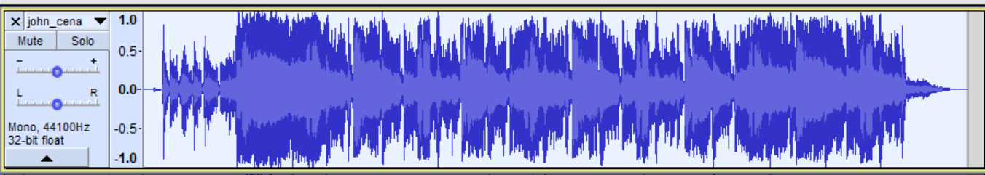

Using Audacity, import the ringtone file being used. Right click in Audacity and select “Mono”. It should split into 2 parts, delete one of the parts. Set the frequency to 8000 Hz at the bottom left, and shorten the clip to less than 10 seconds.

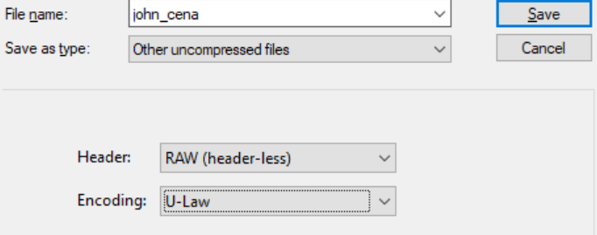

Once editing the file is done, click “File” and select “Export Media”. In the “Save as type” dropdown, choose “Other uncompressed files”. For the “Header” dropdown, choose “Raw (header-less)” and for the “Encoding” dropdown choose “U-Law”. If these settings are not copied exactly, CUCM will not read the file in the server.

Step 3:

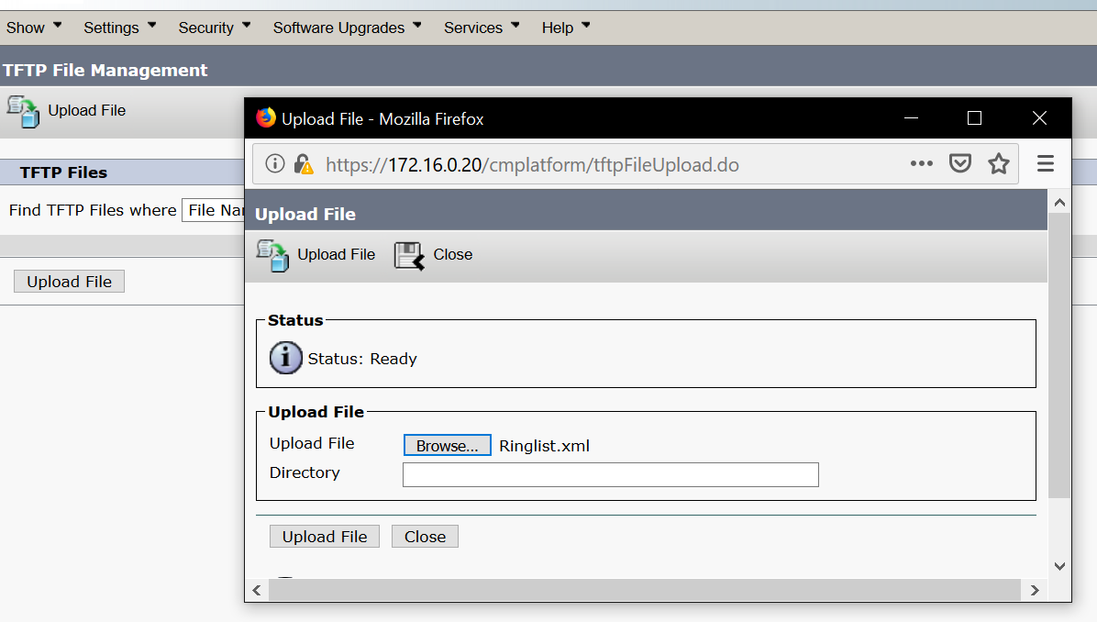

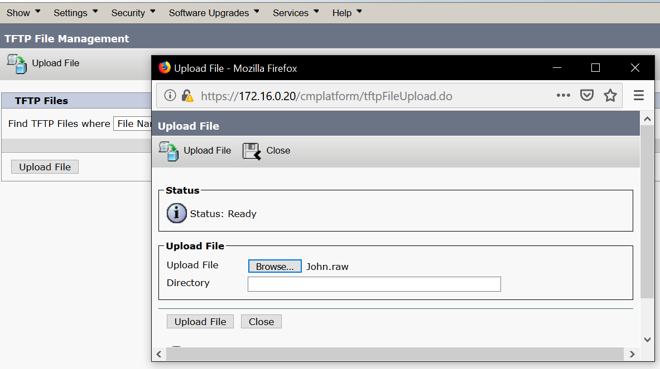

In the navigation tab of CUCM serviceability, choose “TFTP file management” and upload both Ringlist.xml and the ringtone (RAW) file.

**Voicemail Configuration:**

Step 1:

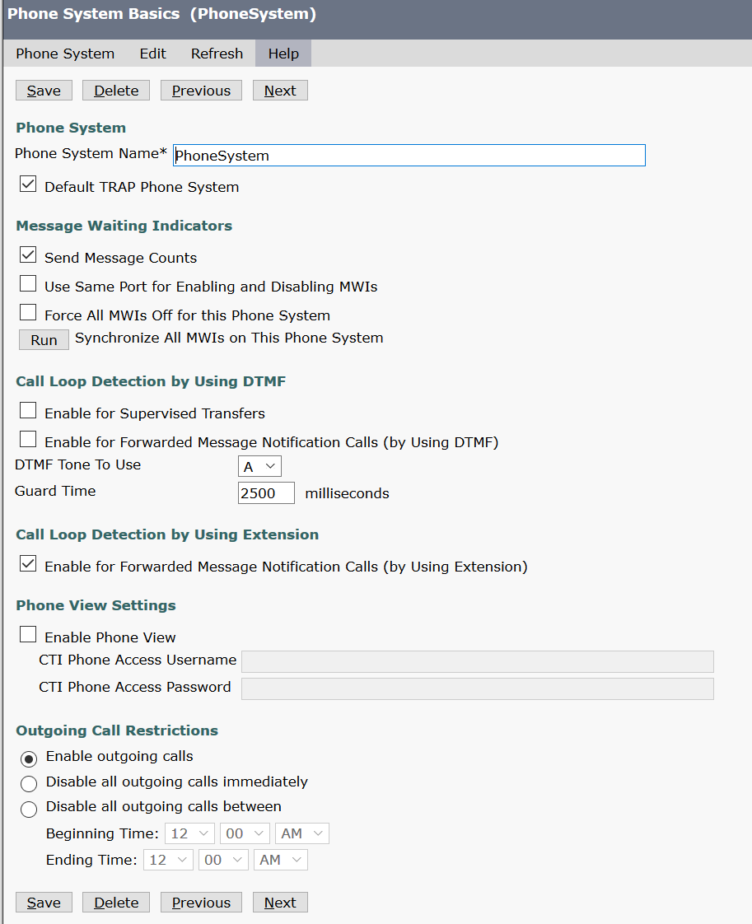

Using the CUC, start by creating a new phone system. The wizard should look like the one shown above. Fill out all the necessary information.

Step 2:

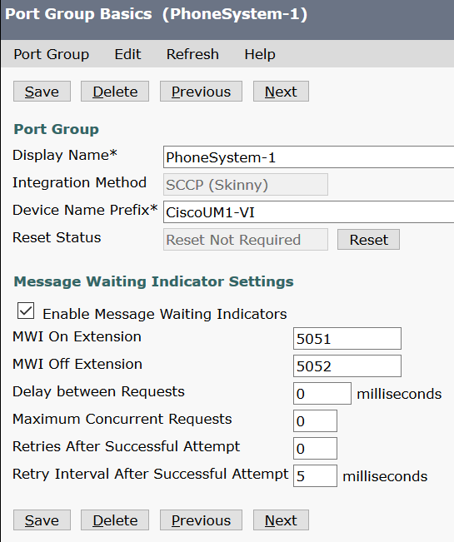

In the Port Group, set the “Display Name” and the “Device Name Prefix” for the phone. MWI stands for “Message Waiting Indication” which tells you if you have voicemail when you call the number. You can choose to turn this feature on or off.

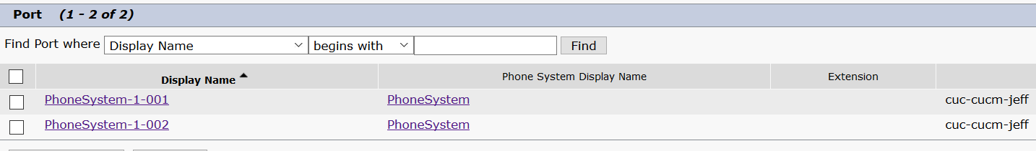

Set up the ports for your two phones.

Step 3:

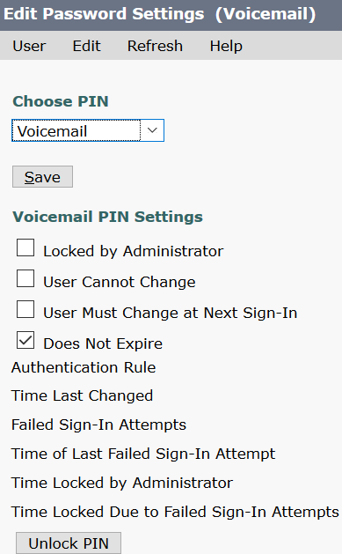

Set up a user profile for both phones.

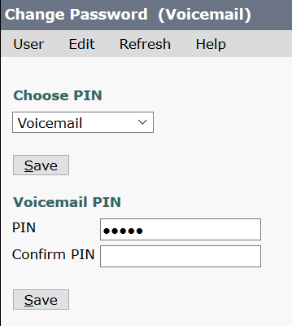

Set a PIN to access voicemail on both phones.

Step 4:

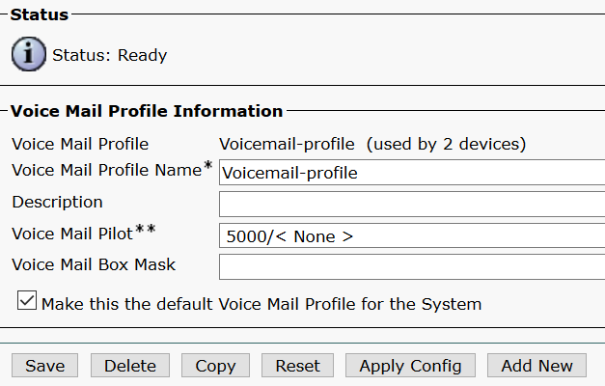

Move to the CUCM for the next steps. Start by setting up the voicemail profile as shown. Make sure you see this wizard.



You should see voicemail ports after making the voicemail profile.

Step 5:

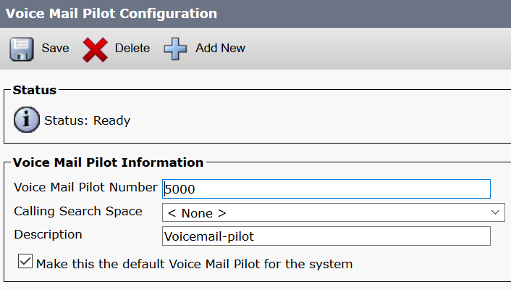

Voicemail pilot is the directory number you dial to access your voicemails.

Set up as shown in the screenshot.

When trying to access your voicemail:

Press the * button.

Dial your phone’s number.

Enter the pin you set earlier to finally access your messages.

Step 6:

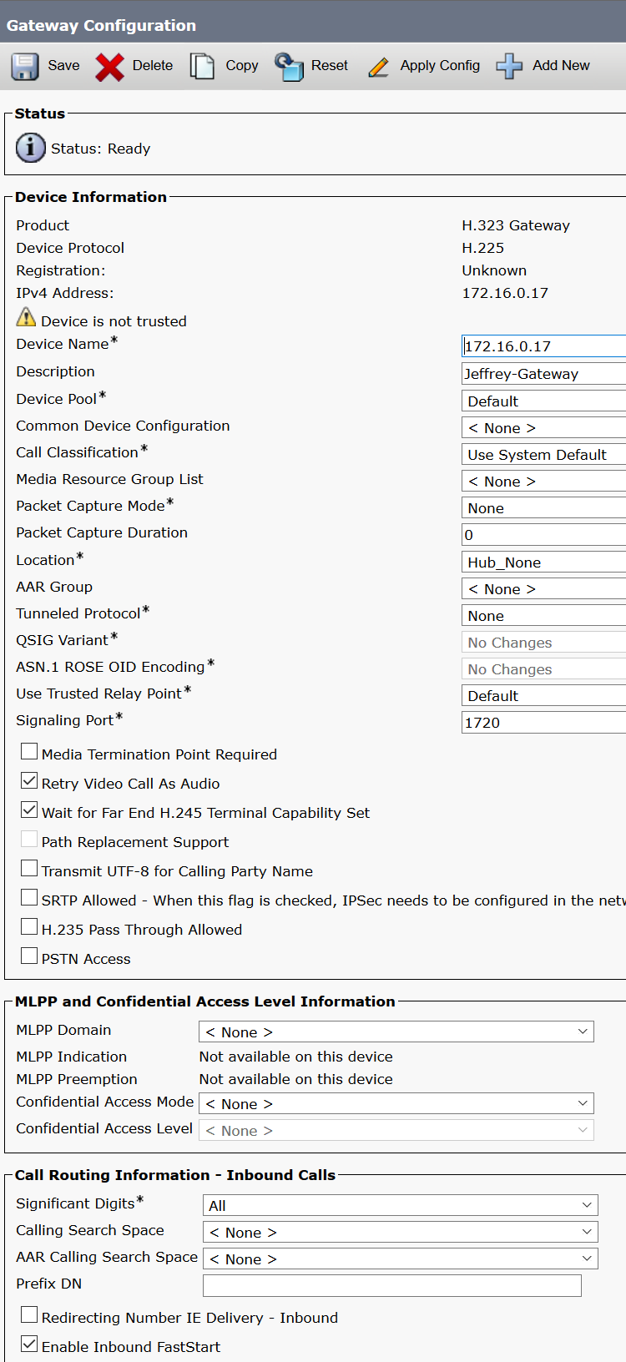

Time for dial in and out. First step is to create a h.323 gateway. In the device tab of the CUCM, choose that option. Set the device name to your router’s ip address. Make sure to check the “Enable Inbound FastStart” checkbox. Fill out all the other asterisk marked fields as shown, or however you prefer.

Step 7:

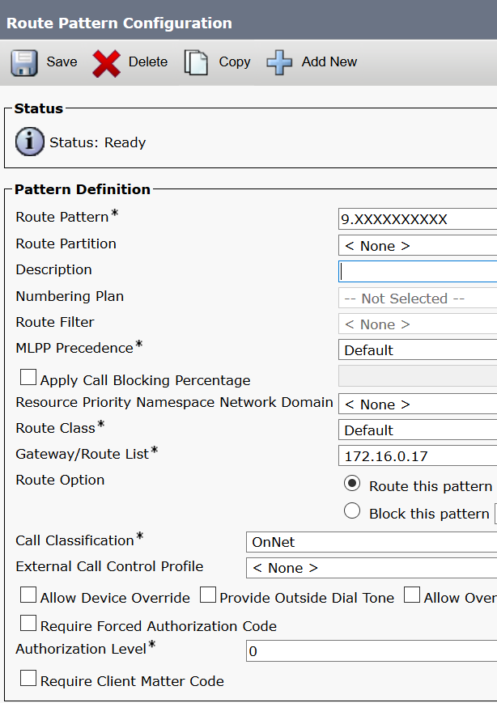

In the “Route and Hunt” tab, choose to create a route pattern. This wizard should pop up. In the “Route Pattern” field enter the text shown above. 9 is the extension, the period represents that everything after the 9 is removed, and the 10 X’s are the phone’s dial number.

Problems: -

We faced countless problems during the whole lab. The first and probably the most annoying problem that we faced was that our VMWare used to constantly crash when we made changes to our virtual machines. The solution that worked for us was that we kept erasing and starting our SSD afresh, until that one time when the VMWare would operate smoothly.

When we actually began the lab, we faced a few problems with establishing connections between the CUC server and the CUCM server. We later realized that we were not properly configuring the Trunk ports between the two servers, due to which, the connections would not work.

While configuring the custom ringtone, when we would try to select the ringtone on the IP Phone, the phone would show a very ironic error message, which would read, “TFTP error log…” We tried numerous different tactics to counter this problem, but unfortunately, none of them worked. When we had lost all hope, we began doing the complete process repeatedly. After countless trials, the ringtone finally worked, and we were able to get our signoff.

Conclusions: -

The lab was successfully completed and the motive of working on this lab was fulfilled. We learnt about numerous communication techniques that, unlike the “Internal VOIP lab,” were not only bound to our separate LAN, but also to the whole world. All the skills that we acquired during the completion of this lab are a huge asset of knowledge to possess for anyone who is interested in pursuing a career in telecommunications. Cisco IP phones are widely used by many companies. For example, if you enter a store that is a part of the Kroger group of companies (like QFC, Fred Meyer, etc.), you are bound to notice a Cisco IP phone there. This concludes that these companies extensively use this technology. Mobile communications industry highly value these skills in an employee too.